

**DONEWIT**

**SUBMITTED TO**

**DEPARTMENT OF COMPUTER SCIENCE**

**SEMSTER 7TH**

**JULY-DEC 2020**

**UNDER THE SUPERVISION OF**

**RIDHIMA RANI**

**SUBMITTED BY**

RACHIT KAPOORPUNIT PUNDIRPULKIT GUPTA

171099161417109916131710991610

**CHITKARA UNIVERSITY**

**CHANDIGARH-PATIALA NATIONAL HIGHWAY, RAJPURA, DISTT. PATIALA**

**PUNJAB, INDIA**

**DECLERATION**

I hereby declare that the project work titled, “DoneWIt” submitted as part of Bachelor’s degree in CSE, at Chitkara University, Punjab is an authentic record of my work carried out under the supervision of Ridhima Rani.

**Place**:

**Verified by:**

**Date:** ___December, 2020

**Group Members Name:**

Rachit Kapoor

Punit Pundir

Pulkit Gupta

**Signature of Supervisor**

**Signatures:**

**ACKNOWLEDGEMENT**

The success and final outcome of this project required a lot of guidance and assistance from many people and we are extremely privileged to have got this all along the completion of our project. All that we have done is only due to such supervision and assistance and we would not forget to thank them.

I respect and thank **Ms. Ridhima Rani**, for providing us an opportunity to do the project work, giving us all support and guidance which made us complete the project duly. We are extremely thankful to her for providing such a nice support and guidance

We are thankful to and fortunate enough to get constant encouragement, support and guidance from all Teaching staffs of Computer Science which helped us in successfully completing our project work.

**___December, 2020 Rachit Kapoor Punit Pundir**

**Pulkit Gupta**

**CONTENTS**

**TITLE PAGE NO.**

* Declaration
* Acknowledgment
* List of Abbreviations
* List of Figures and Tables

1. Introduction 1
2. Literature Survey 2
3. Work Done 3
4. Conclusion and Future Scope 4
5. References 5

**INTRODUCTION**

**DoneWIt** is an initiative to create an easy platform for everyone to sell and buy things.

Do you have band instruments, electronics, jewelry, or other items lying around your house that you no longer use or need? Install our app today.

**LITERATURE SURVEY**

Before beginning with this app we went through many articles on the internet and found a lot of reasons why we should proceed with making this app.

Below are the 3 main benefits of buying and selling used items.

1. The Environment

Buying a used product means that no new resources or energy are required to make that product. This reduces your carbon footprint and is extremely beneficial to the environment. Selling your used items also prevents pollution. Rather than throwing your no longer used item away, you are giving it a new life. Go green and buy used and sell items that you aren't using anymore!

2. Saves/Earns You Money

Selling items you no longer use or need is a great way to get some extra cash that you normally wouldn't have. Buying used items also saves you a lot of money, as used items are normally at least 50% lower than the original price. Your wallet will thank you later!

3. Helps Others

Selling items you no longer need also gives others an opportunity to purchase something they may not have been able to afford at full price. Why throw something away when you can give someone else the ability to have that item at a great price? Buying and selling used also helps your local economy and small businesses, instead of spending your money at large corporations.

So after conducting this online survey we have decided that there is a need of an app for selling and buying used items in this fast paced world.

**WORK DONE**

* **APP DESIGN**

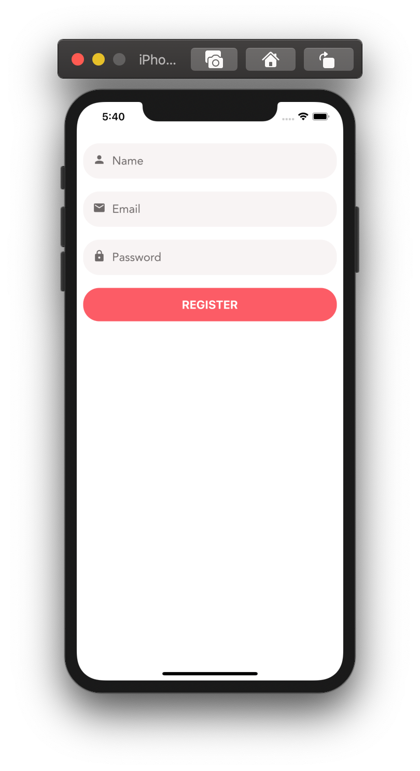

Form

Register Screen

* A screen for registering a new user. This screen is very similar to the login screen

# 

Listing Edit Screen

Here’s the screen for posting a new listing.

Validation rules:

* Title: A required string, minimum one character long
* Price: A number between 1 and 10,000
* Category: A required but nullable object

# 

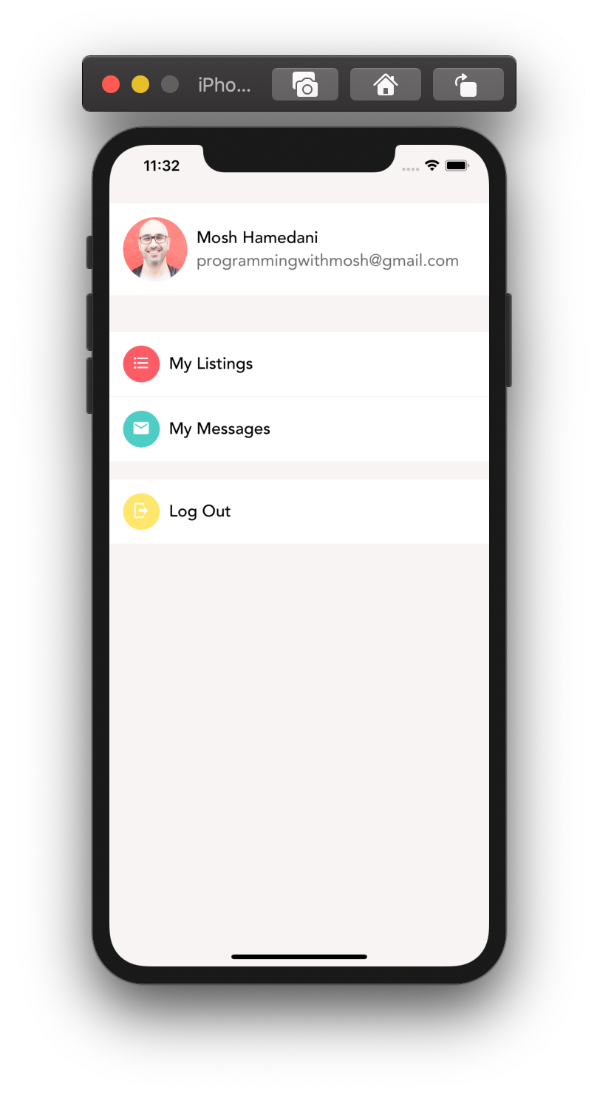

Lists

My Account Screen

This is where the user can view their listings, messages, etc.

For the icons, we used **Material Community Icons set.**

* My Listings: format-list-bulleted
* My Messages: email
* Log Out: logout
* Colour Scheme:
* My Listings: primary
* My Messages: secondary
* Log Out: #ffe66d

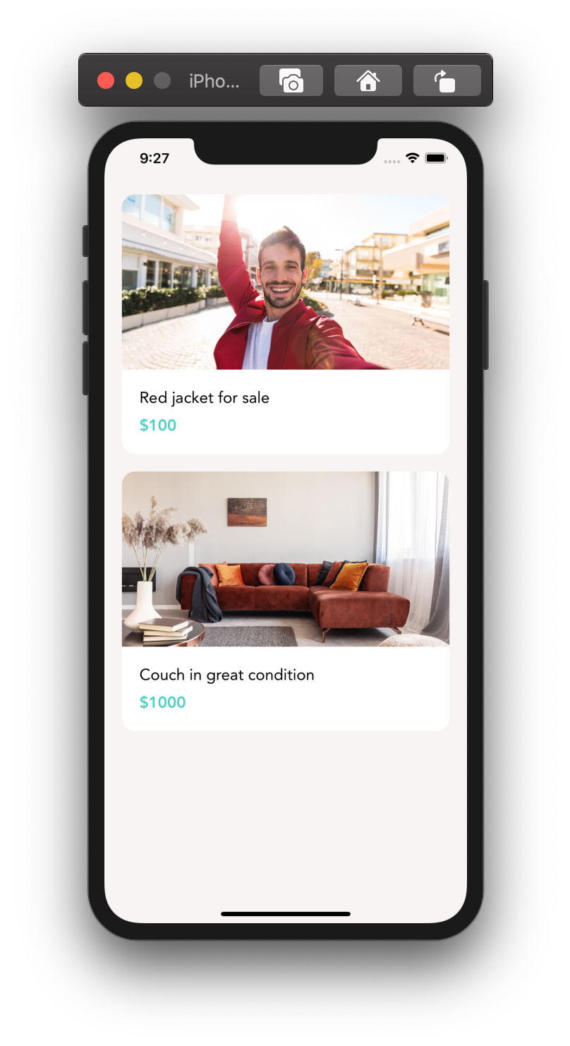

Listings Screen

Here’s the main page of our app that the user will see once they log in

**CONCLUSION AND FUTURE SCOPE**

**Conclusion**

**Future Scope**

**REFERENCES**

1. <https://codewithmosh.com/p/the-ultimate-react-native-course>
2. <https://reactnative.dev/>